**[CDS] How to setup External Dashboard**

**Azure Environment**

1. Login to portal.azure.com, go to Admin Web Application. Add * into allowed origins, which will let all other external web sites accessing CDS Admin Web Application.

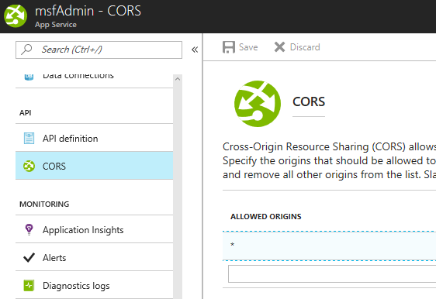

**CDS SuperAdmin Web**

1. Login to CDS SuperAdmin Web Application, find the company which is going to setup external application (for example: Contoso). Edit Company with:

Allow Domain: [www.abc.com](http://www.abc.com); [www.123.com](http://www.123.com)

Press Get Key to generate External Application Key. (This Key will allow your external web application to connect with CDS API Service later)

Press Save button.

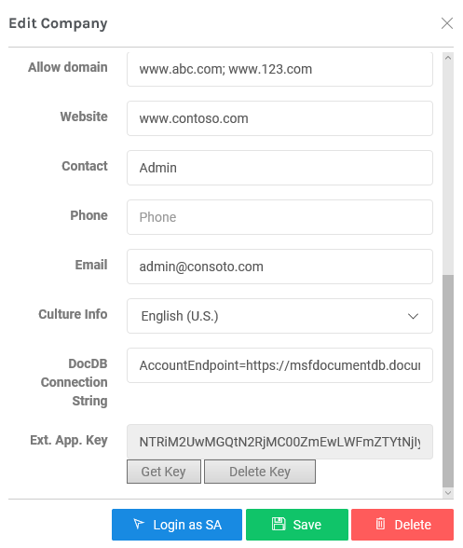

1. Define Dashboard name and URL

Click Dashboard button on Company (Contoso).



Press Add Dashboard button, and input

Order: 1 /* Presentation order on Admin Web */

Dashboard Name: my Dashboard 1 /* The name will present on Admin Web */

Dashboard URL: <http://www.abc.com/index.php> /* same domain defined pre. */

Press Submit button.

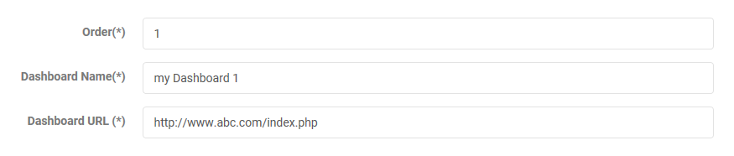

**CDS Admin Web**

1. Login to CDS Admin Web Application, the external dashboard shows under Dashboard menu.

